

***LAB REPORT***

***STUDENTS NAME***

***Abd-ul-Ahad***

***ROLL NO***

***(BSSE-2K24-111-A)***

***SUBJECT NAME***

***(Information & communication technology fundamental)***

***SUBMITTED TO***

***MS. Fabia Hussan***

***SUBMITTED BY***

***Abd-ul-Ahad***

*SESSION 2k24*

***LAB NO. 1***

***LL LAB NO 01***

***Typing practices (Typing Tutor) and***

***internal Components of Computers***

***"Typing Master" refers to a program or software designed to help users improve their typing speed and accuracy. It is typically aimed at teaching touch typing, which involves typing without looking at the keyboard.***

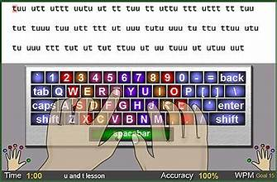

***How typing master Works:***

1. ***Start with a Diagnostic Test:***
   * ***When you first start TypingMaster, it asks you to complete a diagnostic test to evaluate your current typing speed and accuracy.***
   * ***Based on the results, TypingMaster tailors the lessons and exercises to your skill level.***
2. ***Follow the Typing Lessons:***
   * ***You'll be guided through various typing lessons, beginning with the basic home row keys and progressing to more complex combinations.***
   * ***Each lesson teaches you how to type a specific set of keys using the correct fingers, ensuring you develop good habits.***
3. ***Practice with Typing Tests and Games:***
   * ***To reinforce what you've learned, you will frequently take typing tests to measure your progress.***
   * ***Additionally, typing games make the practice more enjoyable and offer challenges that help increase both speed and accuracy.***



1. ***Review Your Progress:***
   * ***After each typing test or lesson, TypingMaster provides detailed feedback, showing your typing speed (WPM), accuracy, and errors.***
   * ***Over time, this data allows you to identify areas where you need improvement.***
2. ***Advanced Features (Pro Version)***
   * ***For those who choose the paid Pro version, TypingMaster offers advanced training features and in-depth analysis, including specific drills for weak areas, personalized lessons, and advanced statistics.***

***Benefits of Using TypingMaster:***

* ***Improved Typing Speed: By focusing on proper finger placement and practicing regularly, you can significantly increase your typing speed.***
* ***Enhanced Accuracy: TypingMaster helps you reduce errors by teaching you how to type without looking at the keyboard, improving both accuracy and confidence.***
* ***Better Productivity: Faster typing speeds lead to improved productivity, whether you're writing documents, coding, or communicating online.***
* ***Fun and Engaging: Typing games and interactive exercises make learning typing more enjoyable, helping you stay motivated throughout the process.***

***Conclusion:***

***TypingMaster is a powerful tool for anyone looking to improve their typing skills, whether for personal development, professional use, or educational purposes. With its structured lessons, interactive exercises, and detailed progress tracking, it provides a well-rounded approach to mastering typing.***

***LAB NO 02***

***Windows installation Cpu Assembling***

***Installing Windows on your computer can seem a bit intimidating, but if you break it down into simple steps, it’s fairly straightforward.*** ***It looks like you are asking for detailed steps on installing Windows on a PC, rather than for the Typing Master software. Let me walk you through the entire process of installing a Windows operating system (e.g., Windows 10 or Windows 11) from scratch.***



***How many step to installation windwos***

***Create a Bootable USB Drive***

***If you don't have a bootable USB, you'll need to create one:***

1. ***Download Windows Installation Media:***
   * ***Visit the*** [***Microsoft Windows 10 download page***](https://www.microsoft.com/en-us/software-download/windows10) ***or*** [***Windows 11 download page***](https://www.microsoft.com/en-us/software-download/windows11)***.***
   * ***Download the Windows Media Creation Tool for your version of Windows.***
2. ***Run the Media Creation Tool:***
   * ***Launch the tool and accept the terms and conditions.***
   * ***Select Create Installation Media (USB Flash Drive, DVD, or ISO file) for another PC.***
   * ***Choose your language, edition (e.g., Windows 10 Home, Windows 10 Pro), and architecture (64-bit or 32-bit).***
3. ***Create Bootable USB:***
   * ***Choose USB Flash Drive as the installation media.***
   * ***Insert a USB drive (at least 8GB in size) into your computer.***
   * ***Select the USB drive from the list of available devices.***
   * ***Click Next, and the tool will download the necessary files and create a bootable USB drive.***

***Step 2: Prepare Your PC for Installation***

***Before you begin installing Windows, make sure your PC is ready:***

1. ***Backup Your Data:***
   * ***If you're installing on a computer with an existing OS, make sure to back up all important files to an external drive or cloud storage.***
2. ***Check System Requirements:***
   * ***Make sure your PC meets the minimum requirements for the version of Windows you’re installing (e.g., Windows 10 or 11). Generally, you'll need a 1 GHz or faster processor, 1 GB (32-bit) or 2 GB (64-bit) RAM, and at least 20 GB of free storage space.***
3. ***Ensure You Have a Valid License Key:***
   * ***You’ll need a valid product key for activation. If you are reinstalling Windows on a machine with a previous activation, you may not need to enter the key during installation, but be ready to do so if prompted.***

***Create a Bootable USB Drive***

***If you don’t already have a bootable USB with Windows on it, you’ll need to create one:***

* ***Download the Windows Media Creation Tool from Microsoft’s website.***
* ***Use it to download the Windows ISO and create a bootable USB (you'll need at least an 8GB USB drive).***
* ***Insert the USB drive into your PC.***

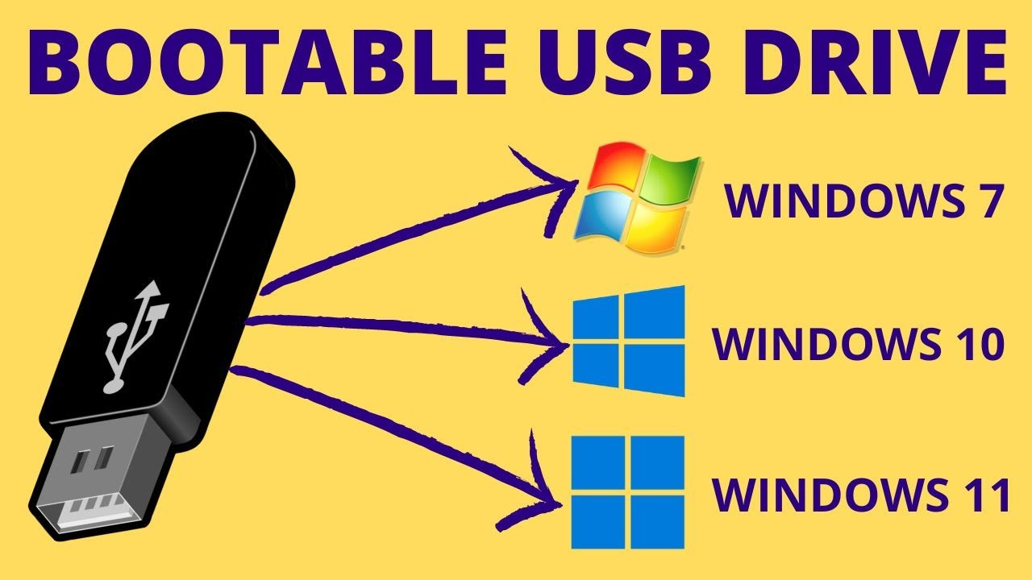

***Insert the Bootable USB***

* ***Plug the bootable USB into your computer.***
* ***Restart the PC.***
* ***Enter BIOS/UEFI: To do this, press a key (usually F2, F12, ESC, or DEL) right after turning on thcomputer. You may see a message like “Press F2 for setup.”***



***3. Boot from USB***

* ***Save the changes in BIOS/UEFI and restart the PC.***
* ***Your PC should now boot from the USB drive, and you’ll see the Windows installation screen.***

***4. Select Language and Preferences***

* ***Choose your language, time, and keyboard preferences. Once you’ve made your selections, click Next.***

***5. Install Windows***

* ***Click Install Now.***
* ***Enter your Windows product key if prompted. (If you don’t have one, you can skip this step and activate Windows later.)***
* ***Select the Windows edition you want to install (Home, Pro, etc.)***

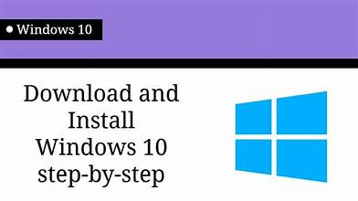

***6. Choose Where to Install Windows***

* ***You will see a list of available drives and partitions. Choose the drive where you want to install Windows (usually the C: drive).***
* ***If you want to perform a fresh install, you can delete existing partitions (WARNING: This will erase everything on the drive).***

***After selecting the drive, click Next.***

***7. Wait for Windo ws to Install***

* ***Windows will begin installing. This process may take 10-30 minutes depending on your PC’s speed.***
* ***Your computer may restart several times during the installation. Don’t worry, that’s normal.***

***8. Set Up Windows***

* ***After installation, you'll be asked to choose basic preferences:***
  + ***Set up a user account and password.***
  + ***Choose privacy settings (you can customize these).***
  + ***Sign in with a Microsoft account (optional, but allows syncing with other devices).***
* ***Activate Windows if you didn’t enter a product key earlier.***

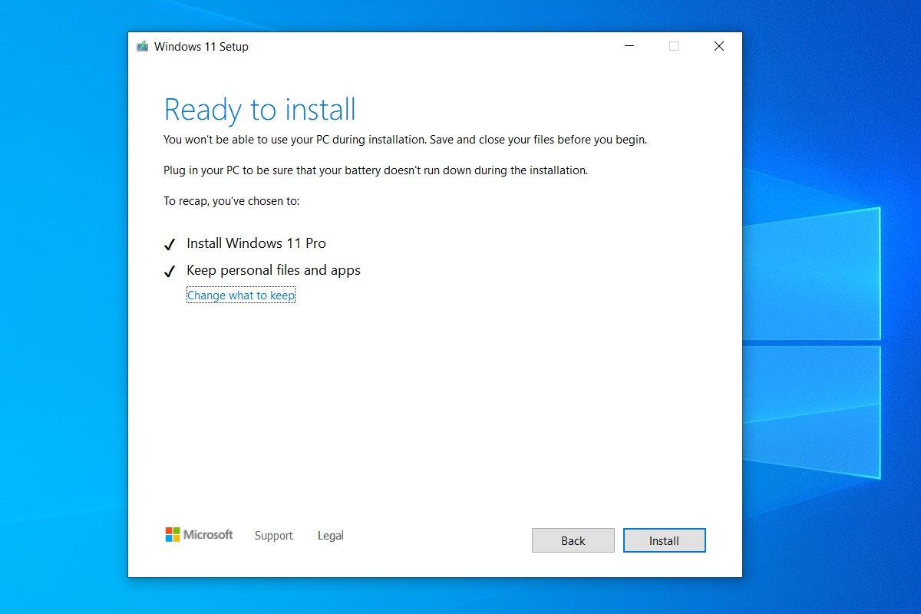

***9. Install Drivers and Updates***

* ***After installation, Windows will begin downloading and installing any necessary drivers (like for your graphics card, network, etc.).***
* ***Once done, check for Windows updates by going to Settings > Update & Security > Windows Update, and install any available updates.***

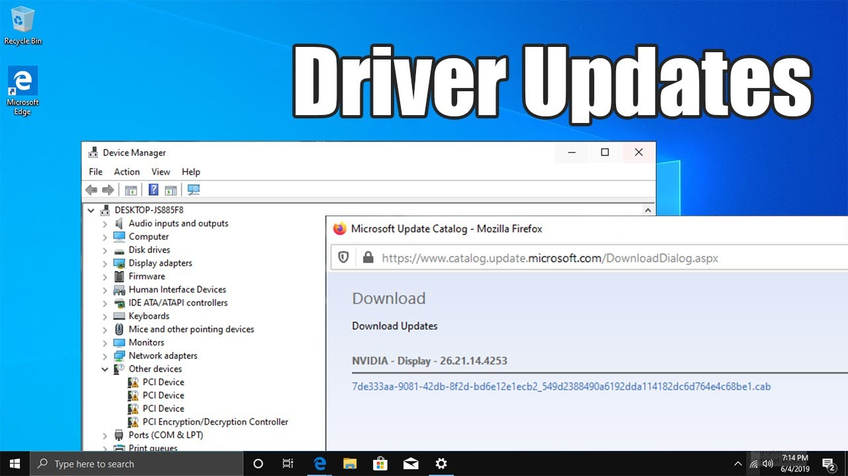

***10. Done!***

* ***Once the setup is complete, your computer will be ready to use with a fresh installation of Windows.***

***LAB NO 03***

***MOTHERBOARDS AND INTERNAL STRUCTURE***

***MOTHERS BOARDS ..***

***A motherboard is the main circuit board in a computer. It connects all the essential components of the computer, like the CPU (central processing unit), RAM (random access memory), storage, and other peripherals, allowing them to communicate with each other.***

***The Backbone of the Computer: Think of the motherboard as the "central hub" or "backbone" of a computer Every part of the computer plugs into the motherboard in some way whether it’s the CPU, memory, hard drives, or graphic card. It provides power and data transfer between all these components***

***A motherboard (also known as a mainboard or mobo) is the central printed circuit board (PCB) in a computer that connects and allows communication between all of the system's components, such as the CPU (central processing unit), RAM (random access memory), storage devices (like hard drives or SSDs), and other peripherals. It's one of the most critical components in a computer, as it determines many of the capabilities and expandability of the system.***

***Key Functions of a Motherboard:***

* ***Holds the CPU: The CPU is mounted on the motherboard in a dedicated socket (often called the CPU socket).***
* ***RAM Slots: These slots hold the computer's memory, which is used by the CPU to store and retrieve data for active tasks.***
* ***PCI Slots: These slots are used to add expansion cards (e.g., graphics cards, sound cards, network cards).***
* ***Storage Connections: Motherboards have connectors like SATA ports for connecting storage devices (HDDs, SSDs) or M.2 slots for high-speed NV Me SSDs.***
* ***Power Distribution: The motherboard provides power to all components via connections to the power supply unit (PSU).***
* ***I/O Ports: The motherboard has USB ports, HDMI, Ethernet ports, and other connectors that allow the computer to interact with external devices.***

***Types of Motherboards:***

***Motherboards come in different sizes and form factors, with the most common ones being:***

***1. ATX (Advanced Technology extended)***

* ***Size: 12 x 9.6 inches (30.5 x 24.4 cm).***
* ***Features: This is the most common and widely used motherboard form factor. It offers ample space for expansion slots, RAM, and other connectors.***
* ***Use: Typically used in desktop computers, gaming PCs, and workstations.***

***2. Micro ATX***

* ***Size: 9.6 x 9.6 inches (24.4 x 24.4 cm).***
* ***Features: A smaller version of the ATX motherboard, it offers fewer expansion slots but still provides a good amount of room for RAM, storage, and other components.***
* ***Use: Used in budget PCs or smaller desktop systems where space is a concern but expandability is still necessary.***

***3. Mini-ITX***

* ***Size: 6.7 x 6.7 inches (17 x 17 cm).***
* ***Features: A very compact motherboard form factor, designed for small form factor (SFF) builds. It typically has limited expansion slots (often just one PCIe slot) but is excellent for compact cases.***
* ***Use: Popular for compact PCs, home theater PCs (HTPCs), and low-power builds.***

***4. E-ATX (Extended ATX)***

* ***Size: 12 x 13 inches (30.5 x 33 cm).***
* ***Features: Larger than standard ATX, offering more room for additional RAM slots, PCIe slots, and other features. It is typically used in high-performance or workstation setups.***
* ***Use: High-end gaming PCs, workstations, and servers.***

***Important Motherboard Components:***

1. ***CPU Socket:***
   * ***The socket on the motherboard where the CPU is installed. Different CPUs (like Intel or AMD) require different sockets, so you need to ensure that the motherboard is compatible with your processor.***
   * ***Common types: LGA (Land Grid Array), PGA (Pin Grid Array), Socket AM4, Socket LGA 1200, etc.***
2. ***RAM Slots:***
   * ***These are slots where RAM sticks are inserted. Motherboards typically have 2 to 4 RAM slots (sometimes more on high-end boards). The more slots available, the higher the amount of memory your system can handle.***
   * ***Important specs: DDR4 or DDR5 RAM support, memory speed (e.g., 3200MHz), and the maximum capacity supported (e.g., 64GB or more).***
3. ***Chipset:***
   * ***The chipset controls data flow between the processor, memory, storage, and peripherals. It plays a significant role in determining the motherboard’s capabilities, including overclocking support, the number of supported expansion slots, and storage types.***
   * ***Common chipsets: Intel Z-series, AMD B-series, X-series, etc.***
4. ***Power Connectors:***
   * ***A motherboard typically requires a 24-pin ATX connector for the main power, plus an additional 4/8-pin connector for CPU power. These connectors supply power to the motherboard and its components.***
5. ***Expansion Slots:***
   * ***These are PCIe (Peripheral Component Interconnect Express) slots where you can add expansion cards like graphics cards (GPU), network cards, sound cards, and more.***
   * ***The most common slots are PCIe x16 (for GPUs) and PCIe x1 (for smaller cards).***
6. ***Storage Connectors:***
   * ***SATA Ports: Used for connecting hard drives (HDDs), solid-state drives (SSDs), and optical drives (like DVD/Blu-ray).***
   * ***M.2 Slots: These slots support modern high-speed NVMe SSDs, which are faster than SATA-based SSDs.***
   * ***U.2 (less common): Used for enterprise-class SSDs, mostly in servers.***
7. ***USB Ports & I/O Ports:***
   * ***Motherboards provide external USB ports (USB-A, USB-C), HDMI, Ethernet, and audio jacks on the rear I/O panel, allowing you to connect various devices such as mice, keyboards, printers, monitors, and speakers.***
8. ***Integrated Graphics:***
   * ***Some motherboards come with built-in graphics capabilities, particularly for processors with integrated graphics (e.g., Intel’s iGPU or AMD’s APU).***
   * ***If your CPU doesn't have an integrated GPU, you’ll need a discrete graphics card (GPU).***
9. ***Audio and Networking:***
   * ***Most modern motherboards have built-in audio chips for sound and Ethernet ports for network connectivity. Some high-end boards also come with Wi-Fi and Bluetooth capabilities.***
10. ***BIOS/UEFI:***

* ***The BIOS (Basic Input Output System) or UEFI (Unified Extensible Firmware Interface) is a firmware embedded on the motherboard that initializes the hardware and provides the interface for configuring system settings.***
* ***UEFI is the modern version of BIOS, offering a more user-friendly interface and additional features, including booting from large drives, secure boot, and faster boot times.***

***Choosing the Right Motherboard:***

***When selecting a motherboard, here are some factors to consider:***

1. ***CPU Compatibility:***
   * ***Make sure the motherboard is compatible with the CPU you want to use (Intel or AMD). Check the socket type (e.g., LGA 1200 for Intel 10th/11th gen CPUs or AM4 for most AMD Ryzen processors).***
2. ***Form Factor:***
   * ***Choose the form factor based on your case size and the number of expansion slots you need. Larger form factors like ATX provide more room for components, but smaller form factors like Micro ATX and Mini-ITX are suitable for compact systems.***
3. ***Chipset Features:***
   * ***The chipset determines how many PCIe slots, RAM slots, and storage connections are available, as well as whether the motherboard supports overclocking and other advanced features. For example, Intel Z-series chipsets and AMD X-series chipsets support overclocking, while lower-end chipsets like the Intel B-series or AMD A-series do not.***
4. ***Expansion Needs:***
   * ***Consider how many PCIe slots (for GPUs, sound cards, network cards) you need, as well as the number of SATA or M.2 ports for storage devices.***
5. ***RAM Capacity:***
   * ***Check how much RAM the motherboard can support and whether it supports modern memory types like DDR4 or DDR5.***
6. ***I/O and Ports:***
   * ***Ensure the motherboard has enough USB ports, Ethernet, and audio outputs for your needs. Some motherboards come with built-in Wi-Fi or Bluetooth if you need those features.***

***Conclusion:***

***The motherboard is a crucial component of any computer system, serving as the backbone that connects all other hardware components. When selecting a motherboard, it’s important to consider factors like CPU compatibility, form factor, chipset features, RAM support, and I/O ports to ensure it meets your needs and system requirements.***

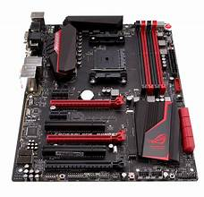

***INTERNAL STRUCTURES***

***The internal structure of a motherboard refers to the components and layout that allow the various parts of the computer to interact. Each part of the motherboard has a specific job, and they work together to manage the power, data, and connections between the CPU, RAM, storage, and other peripherals.***

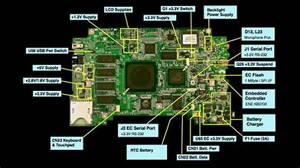

***LAB NO 04***

***INTRODUCTION TO MS OFFICE and MS word Basic Features***

***Microsoft Office is a suite of software programs used for creating documents, presentations, spreadsheets, and other types of content. It's one of the most popular software packages used in homes, schools, and businesses around the world.***

***The main programs in Microsoft Office include:***

1. ***Microsoft Word (for creating documents)***
2. ***Microsoft Excel (for working with spreadsheets)***
3. ***Microsoft PowerPoint (for creating presentations)***
4. ***Microsoft Outlook (for email and calendar management)***
5. ***Microsoft Access (for managing databases)***
6. ***Microsoft OneNote (for note-taking and organizing ideas)***
7. ***Microsoft Word***

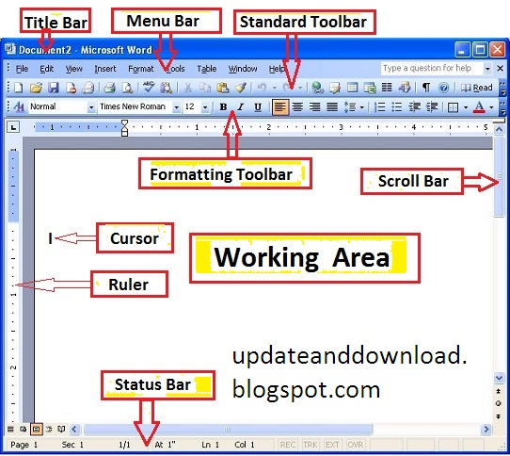

***Microsoft Word is a word processing program, used for creating, editing, formatting, and printing text documents.***

***Example:  
You can use Word to write essays, letters, resumes, reports, and even design newsletters. You can also add images, charts, and change the style of your text using different fonts and colors.***

***How to use it:***

* ***Open Word.***
* ***Start a new blank document or use a template.***
* ***Type your content.***
* ***Use the toolbar to format your text (bold, italic, underline, etc.).***
* ***Save your document when you're done.***

***LAB NO. 5***

***2. Microsoft Excel***

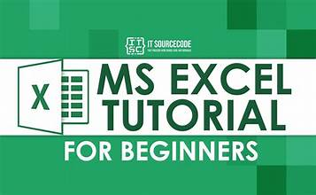***Microsoft Excel is a spreadsheet program, which means it's great for working with numbers, creating tables, and analyzing data.***

***Example:  
If you want to track expenses or create a budget, Excel allows you to make a table with rows and columns to organize your data. You can also use formulas to calculate totals, averages, or percentages.***

***How to use it:***

* ***Open Excel.***
* ***Start with a blank sheet (spreadsheet).***
* ***Enter data into cells (each box is called a "cell").***
* ***Use formulas like =SUM (A1:A5) to add values or =AVERAGE (B1:B5) to find the average.***
* ***Create graphs and charts from your data to visualize it better.***

***EXCEL FROMULA***

*. In Microsoft Excel, a formula is an expression that operates on values in a range of cells. These formulas return a result, even when it is an error. Excel formulas enable you to perform calculations such as addition, subtraction, multiplication, and division.*

* ***SUM***
* *The SUM() function, as the name suggests, gives the total of the selected range of cell values. It performs the mathematical operation which is addition. Here’s an example of it below:*
* ***=SUM(C2:C4)***

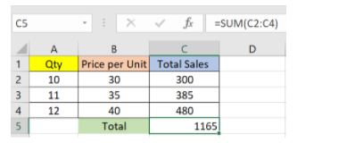

As you can see above, to find the total amount of sales for every unit, we had to simply type in the function “=SUM(C2:C4)”. This automatically adds up 300, 385, and 480

**2. AVERAGE**

The AVERAGE() function focuses on calculating the average of the selected range of cell values. As seen from the below example, to find the avg of the total sales, you have to simply type in:

=AVERAGE(C2, C3, C4)

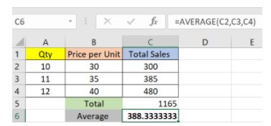

Fig: Average function in Excel

It automatically calculates the average, and you can store the result in your desired location.

***3. COUNT***

The function [COUNT()](https://www.simplilearn.com/tutorials/excel-tutorial/count-in-excel) counts the total number of cells in a range that contains a number. It does not include the cell, which is blank, and the ones that hold data in any other format apart from numeric.

=COUNT(C1:C4)

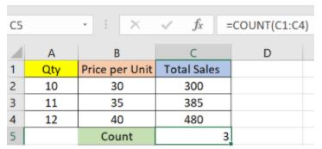

Fig: Microsoft Excel Function - Count

***LAB NO. 6***

***4. SUBTOTAL***

Moving ahead, let’s now understand how the subtotal function works. The SUBTOTAL() function returns the subtotal in a database. Depending on what you want, you can select either average, count, sum, min, max, min, and others. Let’s have a look at two such examples.

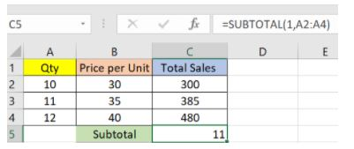

Fig: Subtotal function in Excel

In the example above, we have performed the subtotal calculation on cells ranging from A2 to A4. As you can see, the function used is

=SUBTOTAL(1, A2: A4)

Top Excel Formulas and Functions

Lesson 27 of 81[By Shruti M](https://www.simplilearn.com/authors/shruti-m)

Last updated on Nov 12, 2024243766232



[Previous](https://www.simplilearn.com/tutorials/excel-tutorial/excel-if-function)[Next](https://www.simplilearn.com/tutorials/excel-tutorial/excel-lookup-functions)

Table of Contents

[What is Excel Formula?](https://www.simplilearn.com/tutorials/excel-tutorial/excel-formulas#what_is_excel_formula)

[Formulas in Excel: An Overview](https://www.simplilearn.com/tutorials/excel-tutorial/excel-formulas#formulas_in_excel_an_overview)

[31 Excel Formulas & Functions](https://www.simplilearn.com/tutorials/excel-tutorial/excel-formulas#31_excel_formulas_&_functions)

[Choose the Right Program](https://www.simplilearn.com/tutorials/excel-tutorial/excel-formulas#choose_the_right_program)

[Conclusion](https://www.simplilearn.com/tutorials/excel-tutorial/excel-formulas#conclusion)

View More

Microsoft Excel is the go-to tool for working with data. There are probably a handful of people who haven’t used Excel, given its immense popularity. Excel is a widely used software application in industries today, built to generate reports and business insights. Excel supports several in-built applications that make it easier to use.

One such feature that allows Excel to stand out is - Excel sheet formulas. Here, we will look into the top Excel formulas that one must know while working on Excel. The topics that we will be covering  in this article are as follows:

* What is Excel Formula?
* Excel Formulas and Functions

What is Excel Formula?

In Microsoft Excel, a formula is an expression that operates on values in a range of cells. These formulas return a result, even when it is an error. Excel formulas enable you to perform calculations such as addition, subtraction, multiplication, and division. In addition to these, you can find out averages and [calculate percentages in excel](https://www.simplilearn.com/tutorials/excel-tutorial/calculate-percentage-in-excel) for a range of cells, manipulate date and time values, and do a lot more.

Become an Business Analysis Expert

With Our Unique Program In Collaboration With IBM[Explore Course](https://www.simplilearn.com/business-analyst-certification-training-course?source=GhPreviewCTABanner)

Become an Business Analysis Expert

Formulas in Excel: An Overview

* Choose a cell.
* To enter an equal sign, click the cell and type =.
* Enter the address of a cell in the selected cell or select a cell from the list.
* You need to enter an operator.
* Enter the address of the next cell in the selected cell.
* Press Enter.

There is another term that is very familiar to Excel formulas, and that is "[function](https://www.simplilearn.com/tutorials/excel-tutorial/excel-formulas)". The two words, "formulas" and "functions" are sometimes interchangeable. They are closely related, but yet different. A formula begins with an equal sign. Meanwhile, functions are used to perform complex calculations that cannot be done manually. Functions in excel have names that reflect their intended use.

The example below shows how we have used the multiplication formula manually with the ‘*’ operator.

Sample Formula: "=A2*B2"

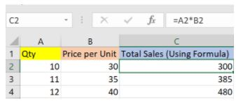

Fig: Microsoft Excel Formula

This example below shows how we have used the function - ‘PRODUCT’ to perform multiplication. As you can see, we didn’t use the mathematical operator here.

Sample Formula: "=PRODUCT(A2,B2)"

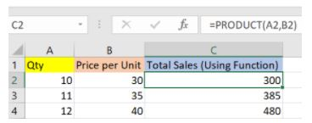

Fig: Microsoft Excel Function

Excel formulas and functions help you perform your tasks efficiently, and it's time-saving. Let's proceed and learn the different types of functions available in Excel and use relevant formulas as and when required.

Become The Highest-Paid Business Analysis Expert

With Business Analyst Master's Program[Explore Now](https://www.simplilearn.com/business-analyst-certification-training-course?source=GhPreviewCTABanner)

Become The Highest-Paid Business Analysis Expert

31 Excel Formulas & Functions

There are plenty of Excel formulas and functions depending on what kind of operation you want to perform on the dataset. We will look into the formulas and functions on mathematical operations, character-text functions, data and time, sumif-countif, and few lookup functions.

Let’s now look at the top 25 Excel formulas you must know. In this article, we have categorized 25 Excel formulas based on their operations. Let’s start with the first Excel formula on our list.

1. SUM

The SUM() function, as the name suggests, gives the total of the selected range of cell values. It performs the mathematical operation which is addition. Here’s an example of it below:

=SUM(C2:C4)



Fig: Sum function in Excel

As you can see above, to find the total amount of sales for every unit, we had to simply type in the function “=SUM(C2:C4)”. This automatically adds up 300, 385, and 480. The result is stored in C5.

2. AVERAGE

The AVERAGE() function focuses on calculating the average of the selected range of cell values. As seen from the below example, to find the avg of the total sales, you have to simply type in:

=AVERAGE(C2, C3, C4)



Fig: Average function in Excel

It automatically calculates the average, and you can store the result in your desired location.

3. COUNT

The function [COUNT()](https://www.simplilearn.com/tutorials/excel-tutorial/count-in-excel) counts the total number of cells in a range that contains a number. It does not include the cell, which is blank, and the ones that hold data in any other format apart from numeric.

=COUNT(C1:C4)



Fig: Microsoft Excel Function - Count

As seen above, here, we are counting from C1 to C4, ideally four cells. But since the COUNT function takes only the cells with numerical values into consideration, the answer is 3 as the cell containing “Total Sales” is omitted here.

If you are required to count all the cells with numerical values, text, and any other data format, you must use the function ‘COUNTA()’. However, COUNTA() does not count any blank cells.

To count the number of blank cells present in a range of cells, COUNTBLANK() is used.

Become a Business Analysis Expert In Just 6 Months

With Our Best-in-class Post Graduate Program[Explore Now](https://www.simplilearn.com/pgp-business-analysis-certification-training-course?source=GhPreviewCTABanner)

Become a Business Analysis Expert In Just 6 Months

4. SUBTOTAL

Moving ahead, let’s now understand how the subtotal function works. The SUBTOTAL() function returns the subtotal in a database. Depending on what you want, you can select either average, count, sum, min, max, min, and others. Let’s have a look at two such examples.



Fig: Subtotal function in Excel

In the example above, we have performed the subtotal calculation on cells ranging from A2 to A4. As you can see, the function used is

=SUBTOTAL(1, A2: A4)

In the subtotal list “1” refers to average. Hence, the above function will give the average of A2: A4 and the answer to it is 11, which is stored in C5. Similarly,

“=SUBTOTAL(4, A2: A4)”

This selects the cell with the maximum value from A2 to A4, which is 12. Incorporating “4” in the function provides the maximum result.

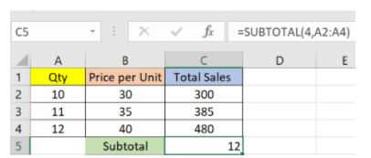

Fig: Count function in Excel

***LAB NO. 7***

***5. MODULUS***

The MOD() function works on returning the remainder when a particular number is divided by a divisor. Let’s now have a look at the examples below for better understanding.

* In the first example, we have divided 10 by 3. The remainder is calculated using the function

      =MOD(A2,3)

* The result is stored in B2. We can also directly type “=MOD(10,3)” as it will give the same answer.

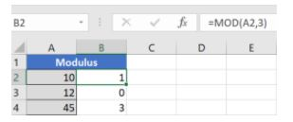

Fig: Modulus function in Excel

Top Excel Formulas and Functions

Lesson 27 of 81[By Shruti M](https://www.simplilearn.com/authors/shruti-m)

Last updated on Nov 12, 2024243766232



[Previous](https://www.simplilearn.com/tutorials/excel-tutorial/excel-if-function)[Next](https://www.simplilearn.com/tutorials/excel-tutorial/excel-lookup-functions)

Table of Contents

[What is Excel Formula?](https://www.simplilearn.com/tutorials/excel-tutorial/excel-formulas#what_is_excel_formula)

[Formulas in Excel: An Overview](https://www.simplilearn.com/tutorials/excel-tutorial/excel-formulas#formulas_in_excel_an_overview)

[31 Excel Formulas & Functions](https://www.simplilearn.com/tutorials/excel-tutorial/excel-formulas#31_excel_formulas_&_functions)

[Choose the Right Program](https://www.simplilearn.com/tutorials/excel-tutorial/excel-formulas#choose_the_right_program)

[Conclusion](https://www.simplilearn.com/tutorials/excel-tutorial/excel-formulas#conclusion)

View More

Microsoft Excel is the go-to tool for working with data. There are probably a handful of people who haven’t used Excel, given its immense popularity. Excel is a widely used software application in industries today, built to generate reports and business insights. Excel supports several in-built applications that make it easier to use.

One such feature that allows Excel to stand out is - Excel sheet formulas. Here, we will look into the top Excel formulas that one must know while working on Excel. The topics that we will be covering  in this article are as follows:

* What is Excel Formula?
* Excel Formulas and Functions

What is Excel Formula?

In Microsoft Excel, a formula is an expression that operates on values in a range of cells. These formulas return a result, even when it is an error. Excel formulas enable you to perform calculations such as addition, subtraction, multiplication, and division. In addition to these, you can find out averages and [calculate percentages in excel](https://www.simplilearn.com/tutorials/excel-tutorial/calculate-percentage-in-excel) for a range of cells, manipulate date and time values, and do a lot more.

Become an Business Analysis Expert

With Our Unique Program In Collaboration With IBM[Explore Course](https://www.simplilearn.com/business-analyst-certification-training-course?source=GhPreviewCTABanner)

Become an Business Analysis Expert

Formulas in Excel: An Overview

* Choose a cell.
* To enter an equal sign, click the cell and type =.
* Enter the address of a cell in the selected cell or select a cell from the list.
* You need to enter an operator.
* Enter the address of the next cell in the selected cell.
* Press Enter.

There is another term that is very familiar to Excel formulas, and that is "[function](https://www.simplilearn.com/tutorials/excel-tutorial/excel-formulas)". The two words, "formulas" and "functions" are sometimes interchangeable. They are closely related, but yet different. A formula begins with an equal sign. Meanwhile, functions are used to perform complex calculations that cannot be done manually. Functions in excel have names that reflect their intended use.

The example below shows how we have used the multiplication formula manually with the ‘*’ operator.

Sample Formula: "=A2*B2"



Fig: Microsoft Excel Formula

This example below shows how we have used the function - ‘PRODUCT’ to perform multiplication. As you can see, we didn’t use the mathematical operator here.

Sample Formula: "=PRODUCT(A2,B2)"



Fig: Microsoft Excel Function

Excel formulas and functions help you perform your tasks efficiently, and it's time-saving. Let's proceed and learn the different types of functions available in Excel and use relevant formulas as and when required.

Become The Highest-Paid Business Analysis Expert

With Business Analyst Master's Program[Explore Now](https://www.simplilearn.com/business-analyst-certification-training-course?source=GhPreviewCTABanner)

Become The Highest-Paid Business Analysis Expert

31 Excel Formulas & Functions

There are plenty of Excel formulas and functions depending on what kind of operation you want to perform on the dataset. We will look into the formulas and functions on mathematical operations, character-text functions, data and time, sumif-countif, and few lookup functions.

Let’s now look at the top 25 Excel formulas you must know. In this article, we have categorized 25 Excel formulas based on their operations. Let’s start with the first Excel formula on our list.

1. SUM

The SUM() function, as the name suggests, gives the total of the selected range of cell values. It performs the mathematical operation which is addition. Here’s an example of it below:

=SUM(C2:C4)



Fig: Sum function in Excel

As you can see above, to find the total amount of sales for every unit, we had to simply type in the function “=SUM(C2:C4)”. This automatically adds up 300, 385, and 480. The result is stored in C5.

2. AVERAGE

The AVERAGE() function focuses on calculating the average of the selected range of cell values. As seen from the below example, to find the avg of the total sales, you have to simply type in:

=AVERAGE(C2, C3, C4)



Fig: Average function in Excel

It automatically calculates the average, and you can store the result in your desired location.

3. COUNT

The function [COUNT()](https://www.simplilearn.com/tutorials/excel-tutorial/count-in-excel) counts the total number of cells in a range that contains a number. It does not include the cell, which is blank, and the ones that hold data in any other format apart from numeric.

=COUNT(C1:C4)



Fig: Microsoft Excel Function - Count

As seen above, here, we are counting from C1 to C4, ideally four cells. But since the COUNT function takes only the cells with numerical values into consideration, the answer is 3 as the cell containing “Total Sales” is omitted here.

If you are required to count all the cells with numerical values, text, and any other data format, you must use the function ‘COUNTA()’. However, COUNTA() does not count any blank cells.

To count the number of blank cells present in a range of cells, COUNTBLANK() is used.

Become a Business Analysis Expert In Just 6 Months

With Our Best-in-class Post Graduate Program[Explore Now](https://www.simplilearn.com/pgp-business-analysis-certification-training-course?source=GhPreviewCTABanner)

Become a Business Analysis Expert In Just 6 Months

4. SUBTOTAL

Moving ahead, let’s now understand how the subtotal function works. The SUBTOTAL() function returns the subtotal in a database. Depending on what you want, you can select either average, count, sum, min, max, min, and others. Let’s have a look at two such examples.



Fig: Subtotal function in Excel

In the example above, we have performed the subtotal calculation on cells ranging from A2 to A4. As you can see, the function used is

=SUBTOTAL(1, A2: A4)

In the subtotal list “1” refers to average. Hence, the above function will give the average of A2: A4 and the answer to it is 11, which is stored in C5. Similarly,

“=SUBTOTAL(4, A2: A4)”

This selects the cell with the maximum value from A2 to A4, which is 12. Incorporating “4” in the function provides the maximum result.



Fig: Count function in Excel

5. MODULUS

The MOD() function works on returning the remainder when a particular number is divided by a divisor. Let’s now have a look at the examples below for better understanding.

* In the first example, we have divided 10 by 3. The remainder is calculated using the function

      =MOD(A2,3)

* The result is stored in B2. We can also directly type “=MOD(10,3)” as it will give the same answer.



Fig: Modulus function in Excel

* Similarly, here, we have divided 12 by 4. The remainder is 0 is, which is stored in B3.

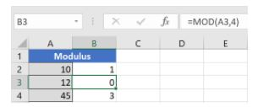

Fig: Modulus function in Excel

Become an AI-powered Business Analyst

Become an AI-powered Business Analyst With Purdue University's Business Analysis Program[Explore Now](https://www.simplilearn.com/pgp-business-analysis-certification-training-course?source=GhPreviewCTABanner)

***LAB NO. 8***

***6. POWER***

The function “Power()” returns the result of a number raised to a certain power. Let’s have a look at the examples shown below:

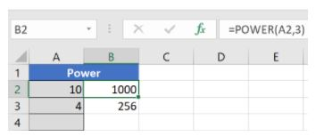

Fig: Power function in Excel

As you can see above, to find the power of 10 stored in A2 raised to 3, we have to type:

=POWER(A2,3)

*07 IF Formula*

The [IF() function](https://www.simplilearn.com/tutorials/excel-tutorial/excel-if-function) checks a given condition and returns a particular value if it is TRUE. It will return another value if the condition is FALSE.

In the below example, we want to check if the value in cell A2 is greater than 5. If it’s greater than 5, the function will return “Yes 4 is greater”, else it will return “No”.

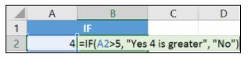

                     Fig: If function in Excel

***COUNTIF***

The function COUNTIF() is used to count the total number of cells within a range that meet the given condition.

Below is a coronavirus sample dataset with information regarding the coronavirus cases and deaths in each country and region.

***LAB NO. 9***

***3. Microsoft PowerPoint***

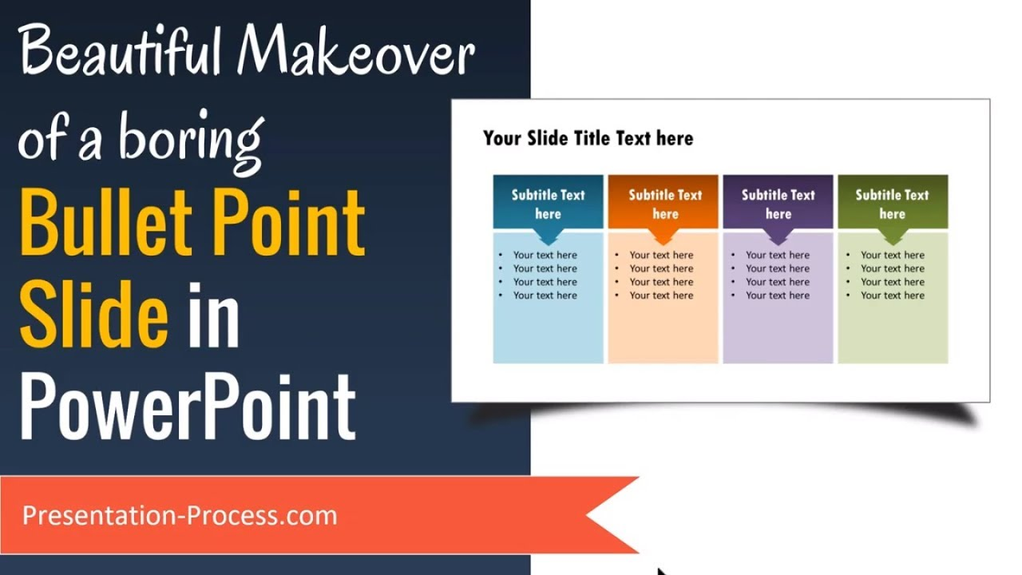

***Microsoft PowerPoint is a program for creating presentations, often used in meetings or classrooms to display information in a visual format.***

***Example:  
You can use PowerPoint to make a slideshow for a school project or a business presentation. It allows you to add text, images, animations, and even videos to each slide.***

***How to use it:***

* ***Open PowerPoint.***
* ***Start with a blank presentation or choose a template.***
* ***Add text and images to slides.***
* ***Apply transitions or animations to make the presentation more dynamic.***
* ***Save and present your slides to your audience.*** 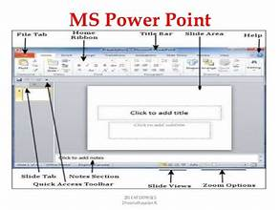

***LAB NO. 10***

***4. Microsoft Outlook***



***Outlook is an email and calendar management program. It's used for sending and receiving emails, scheduling meetings, and organizing tasks.***

***Example:  
If you’re working on a project and need to send emails to your teammates, Outlook lets you send messages, set reminders, and track your appointments or meetings.***

***How to use it:***

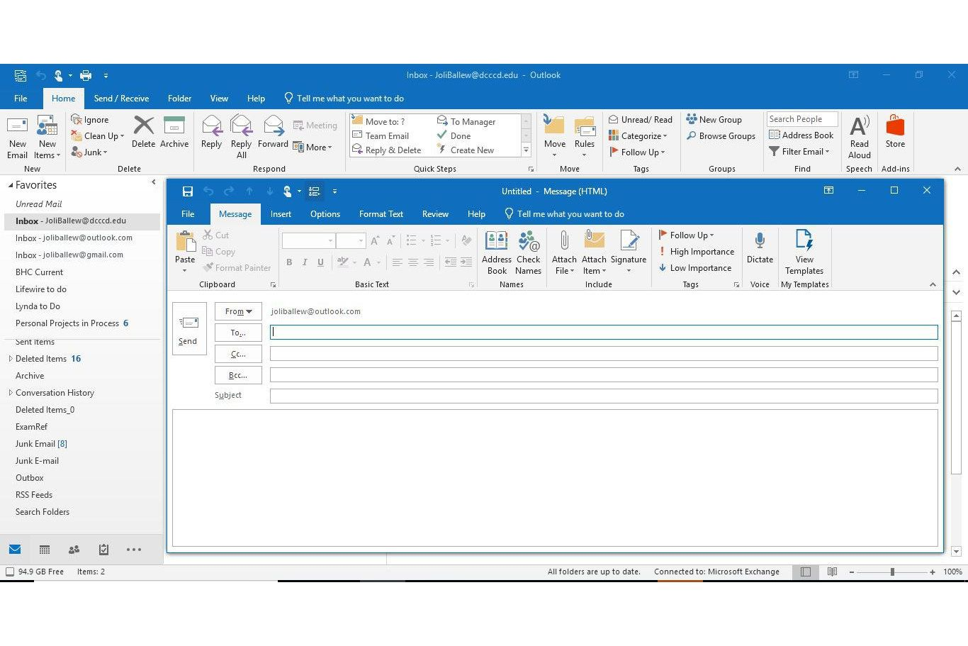 ***. Open Outlook***

* ***Use the "New Email" button to create and send an email.***
* ***Use the "Calendar" feature to schedule meetings or appointments.***
* ***You can also add contacts and keep track of your tasks.***

***5. Microsoft Access***

***What is it?  
Microsoft Access is a database management program used to store and organize large amounts of data in tables, and to create reports based on that data.***

***Example:  
If you're running a small business and need to store customer information, inventory data, or sales records, Access helps you set up a structured database and easily retrieve the information when needed.***

***How to use it:***

* ***Open Access.***
* ***Create a new database.***
* ***Add tables to store data.***

***LAB NO 11***

***Ms. Word Advanced Features Mail Merge, Tables of Contents Section Breaks References , Headers \ footers Microsoft Word offers a wide range of advanced features that can significantly improve your productivity, document formatting, and collaboration. Here are some of the most notable advanced features in MS Word:***

***1. Styles and Themes***

* ***Styles: Word includes built-in styles for headings, paragraphs, and other document elements. You can also create custom styles to ensure consistent formatting across long documents.***
* ***Themes: Pre-designed sets of colors, fonts, and effects can be applied to give your document a***

***rofessional look.***

* ***cohesive and p***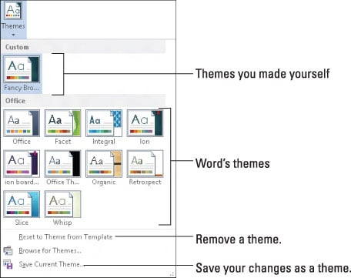

***2. Table of Contents***

* ***You can create a Table of Contents (TOC) that automatically updates as you edit the document. By using heading styles, Word can generate a TOC that reflects the structure of your content.***

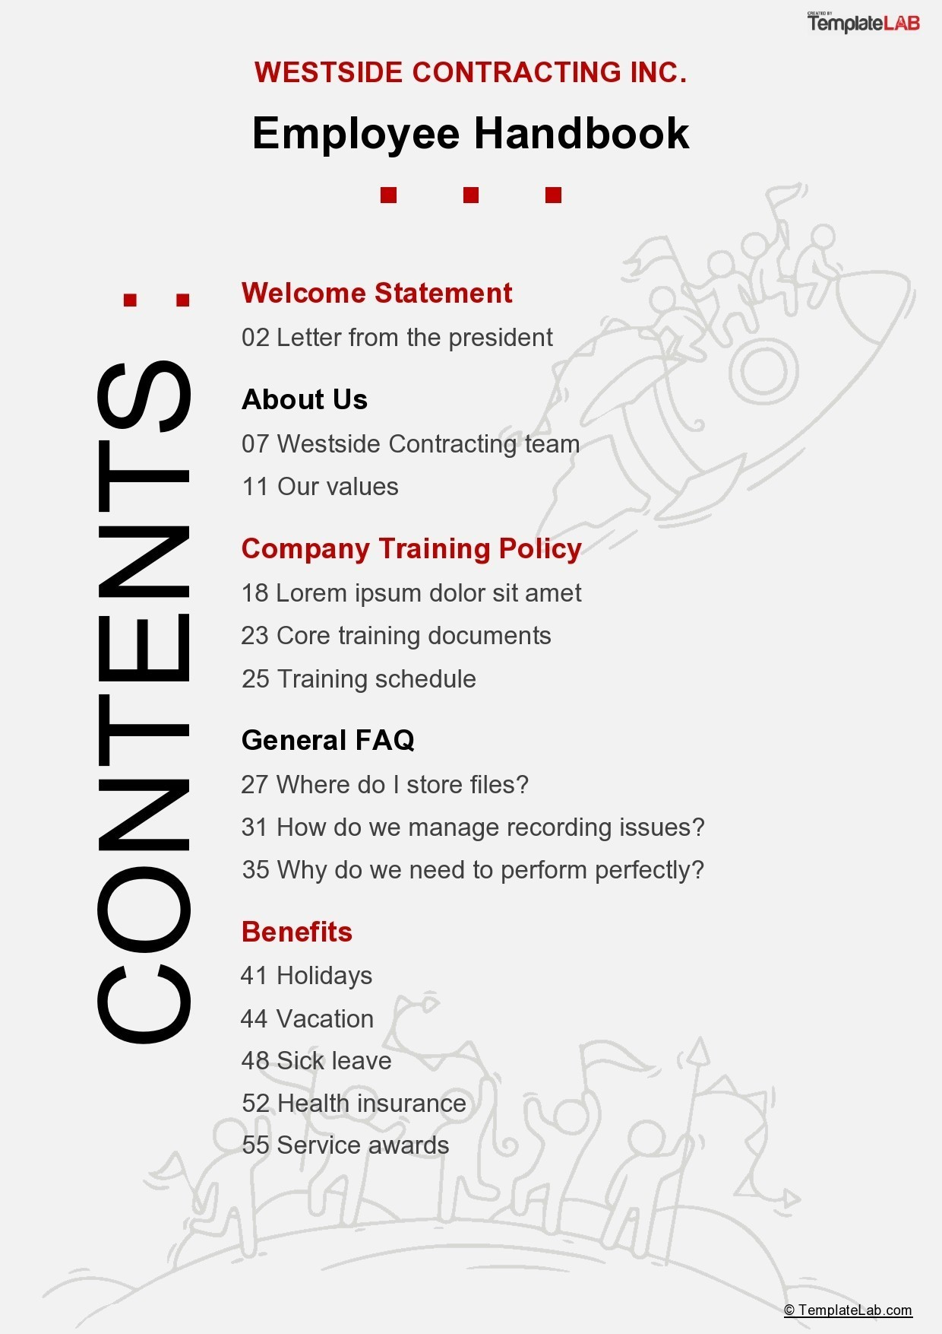

***3. Track Changes and Comments***

* ***Track Changes: Ideal for collaborative work, this feature lets you see edits made by others in a document. You can accept or reject changes, making it easier to review modifications.***
* ***Comments: You can add comments in the margins of a document, making it easier to annotate and discuss changes with others.***

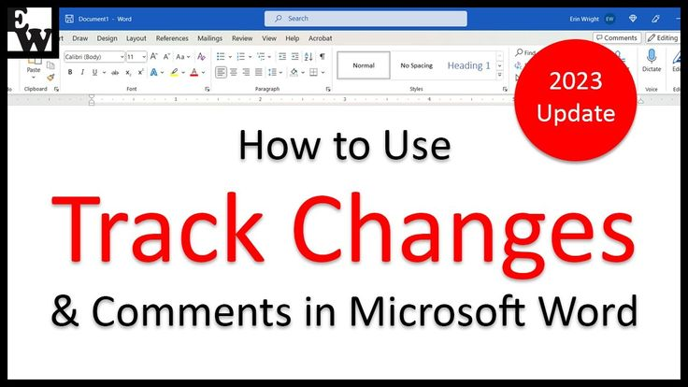

***4. Mail Merge***

* ***Mail Merge allows you to send personalized documents (like letters, labels, and envelopes) to multiple recipients using data from an external source, such as an Excel spreadsheet.***

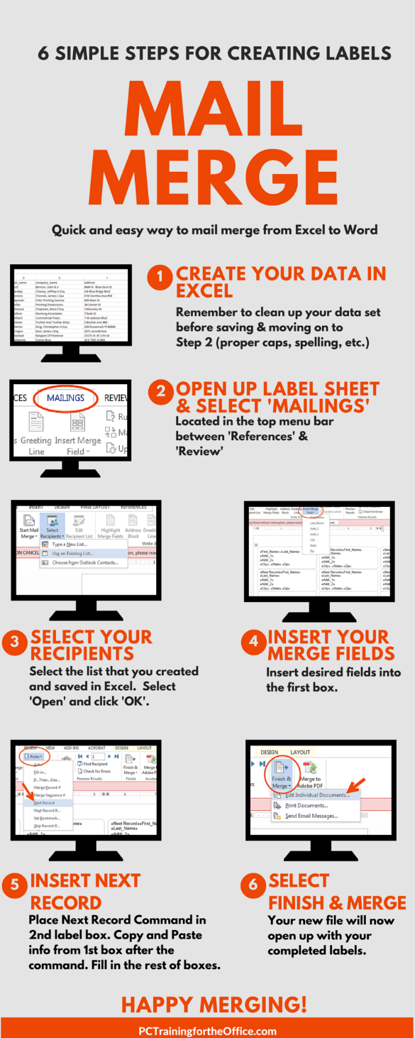

***5. Cross-references and Hyperlinks***

* ***Cross-references: Link to specific parts of the document (like figures, tables, or sections) that automatically update when you edit or move content.***
* ***Hyperlinks: You can insert hyperlinks to external websites, email addresses, or other parts of the document, creating dynamic navigation.***

***6. Advanced Formatting (Columns, Breaks, Text Boxes)***

* ***Columns: Create multiple columns in your document, such as for newsletters or magazines.***
* ***Section Breaks: Insert section breaks to apply different formatting (margins, columns, page orientation) to different parts of the document.***
* ***Text Boxes: Insert and position text boxes within your document to create complex layouts.***

***7. SmartArt and Graphics***

* ***SmartArt: Use SmartArt to create diagrams, flowcharts, and organizational charts that automatically adjust as you add or remove content.***
* ***Images and Graphics: Insert and format images, icons, and graphics with advanced options like text wrapping, position adjustments, and alignment.***

***8. Macros***

* ***Macros: Automate repetitive tasks by recording a series of actions. You can then run the macro to perform those actions at the click of a button.***

***9. Equations and Formulas***

* ***Insert complex mathematical equations using Word's built-in equation editor, which supports LaTeX-style input and offers a wide range of symbols and formatting options.***

***10. Document Protection and Encryption***

* ***Password Protection: Encrypt a document with a password to prevent unauthorized access.***
* ***Restrict Editing: Limit editing to certain parts of the document or restrict formatting changes to ensure the document remains consistent.***

***11. Navigation Pane***

* ***Use the Navigation Pane to quickly jump between sections, headings, and pages of your document, especially useful in long documents. You can also use it to reorder sections or headings easily.***

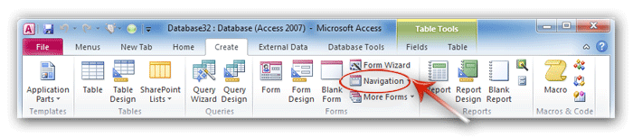

***12. Comparing and Merging Documents***

* ***Compare: You can compare two versions of a document side by side and see the differences highlighted.***
* ***Merge: Merging allows you to combine edits from different people or versions of a document into a single final version.***

***13. Forms and Form Fields***

* ***Create fillable forms in Word with interactive fields like checkboxes, drop-down lists, and text fields, and then protect the document to prevent unauthorized edits.***

***14. Voice Dictation***

* ***MS Word has integrated voice recognition, allowing you to dictate text instead of typing. This feature is available in Word for Microsoft 365 and can help speed up writing.***

***15. Accessibility Features***

* ***Word has built-in tools like Read Aloud and the Accessibility Checker, which help ensure that your document is accessible to people with disabilities. You can check for issues like missing alt text for images or poor color contrast.***

***16. Document Inspector***

* ***Before sharing a document, you can use the Document Inspector to remove hidden metadata, comments, personal information, and revisions.***

***17. Version History***

* ***If you're working on a document in OneDrive or SharePoint, you can access previous versions of the document and restore them if needed.***

***18. Custom Shortcuts and Quick Parts***

* ***Custom Shortcuts: Set up your own keyboard shortcuts for frequently used commands.***
* ***Quick Parts: Save commonly used text (like boilerplate language, signatures, or headers) and insert them with a few clicks.***

***19. Translation and Language Tools***

* ***Translation: Word offers built-in translation tools to translate selected text or entire documents between different languages.***
* ***Language Settings: Set different languages for spell check, grammar, and style guidelines.***

***20. Collaborative Features in the Cloud***

* ***Real-Time Collaboration: Multiple users can edit a document simultaneously if it’s stored in OneDrive or SharePoint. Changes are reflected in real time, and you can see who made each edit.***
* ***Comments and Use in comments to tag collaborators, ensuring they get notified.***

***21. Citations and Bibliography***

* ***Word includes a Citation Manager to insert citations in various styles (APA, MLA, Chicago, etc.) and automatically generate a bibliography based on those citations.***

***22. Outlining and Document Structuring***

* ***Word's Outline View helps you organize long documents by showing a hierarchical structure of headings and subheadings. You can move sections around and restructure the document easily.***

***By mastering these advanced features, you can take your document creation and editing to the next level, whether you're working on a complex report, collaborative project, or professional publication.***

***LAB NO 12***

***Objective***

*Explores tools like Mendeley, Grammarly pdf Elements , Macros pdf to word conversion rerferencing tools and footnotes\ endnotes to enhance docments managements automation , and quality .*

***01 Mendeley***

*Mendeley is a reference management software and academic social network. It is widely used by researchers, students, and academics to manage and share research papers*

*Key Features:*

* ***Reference Management****: Mendeley helps organize and store research papers, articles, and references. You can create a library of your academic sources and organize them by folders or tags.*
* ***Citation Generation****: It automatically generates citations and bibliographies in various citation styles like APA, MLA, Chicago, and more. It integrates with word processors like Microsoft Word to insert citations directly into your work.*
* ***PDF Annotation****: You can read and annotate PDFs directly in the Mendeley desktop app.*
* ***Collaboration****: Mendeley allows users to collaborate with others by sharing documents, notes, and citations in private or public groups.*
* ***Cloud Storage****: It provides cloud-based storage for your research materials, making them accessible from different devices.*

***2. Grammarly:***

***Grammarly is a writing assistant tool that helps users with grammar, spelling, punctuation, style, and clarity. It uses artificial intelligence to analyze and improve written content.***

* ***Key Features:***
  + ***Grammar and Spelling Checks: Grammarly checks for errors in grammar, spelling, and punctuation.***
  + ***Writing Style Suggestions: It offers suggestions to improve sentence structure, clarity, tone, and overall readability. It can detect formal vs. informal tones, conciseness, and other stylistic preferences.***
  + ***Plagiarism Checker: Grammarly also provides a plagiarism detection feature to ensure the content is original and properly cited.***
  + ***Vocabulary Enhancement: It suggests more effective or varied word choices to improve the richness and precision of your writing.***
  + ***Tone Detection: Grammarly detects the tone of your writing, helping you to adjust it to be more friendly, formal, confident, or neutral, depending on the context.***
* ***Usage: Mainly used by students, professionals, and anyone who writes regularly to improve the quality of their written communication, whether it’s emails, essays, reports, or even social media posts.***

***Summary of Differences:***

* ***Mendeley is focused on academic research, reference management, and collaboration.***
* ***Grammarly is a general writing assistant tool that focuses on improving grammar, style, and clarity across all types of writing.***
* ***PDF Element***

***PDF Element is a popular PDF editing software that offers a wide range of features for creating, editing, annotating, and converting PDF files. One of its features is the ability to convert PDFs to different formats, including Word documents.***

***When it comes to PDF to Word conversion, this process involves transforming a PDF (which is a fixed-format file) into a Word document (.doc or .docx), allowing you to edit and modify the content in Word. Here's how PDF Element can help with this:***

***Key Features of PDF Element for PDF to Word Conversion:***

1. ***Accurate Conversion: PDF Element ensures that the formatting, text, and images in the PDF are retained as much as possible when converting to Word. It attempts to keep the layout, fonts, and tables consistent.***
2. ***Batch Conversion: If you have multiple PDF files to convert, PDF Element allows batch conversion, saving time and effort.***
3. ***Editable Text: After conversion, the resulting Word document allows you to edit the text, make changes to formatting, and adjust the content as needed.***
4. ***OCR (Optical Character Recognition): PDF Element includes OCR technology for converting scanned or image-based PDFs (such as scanned forms or documents) into editable text. This can be especially useful if you're converting scanned PDFs that contain images or non-selectable text.***
5. ***Simple Interface: The tool is designed to be user-friendly, with an intuitive interface where you can drag and drop files, or use the “Convert” feature to select your output format (e.g., Word).***

***Steps to Convert PDF to Word using PDF Element:***

1. ***Open PDF Element on your computer.***
2. ***Import the PDF file you want to convert by clicking on the "Open File" button or dragging the file into the program.***
3. ***Select the "Convert" tab: Once the file is open, click on the "Convert" button in the toolbar.***
4. ***Choose the Word format: From the conversion options, choose "To Word" to convert the PDF into a .doc or .docx format.***
5. ***Customize settings (optional): You can adjust conversion settings if needed, such as selecting to include or exclude images, text, or formatting.***
6. ***Click Convert: After selecting your preferences, click on the "Convert" button to initiate the process.***
7. ***Save the Word document: Once the conversion is complete, save the new Word file to your desired location.***

***Benefits of Using PDF Element for PDF to Word Conversion:***

* ***Preserves Layout & Formatting: PDF Element aims to maintain the layout, images, tables, and text formatting when converting to Word.***
* ***Easy Editing: Converting to Word makes it easier to edit and make adjustments to the content, which might be difficult in a PDF.***
* ***OCR Support: With OCR, you can also convert scanned documents into editable text, a feature that many other PDF converters lack.***

***Macros in PDF Element:***

***PDF Element also supports Macros for automating repetitive tasks. While macros in PDF Element aren't specifically related to PDF to Word conversion, they can be used to automate workflows, such as batch converting multiple files or applying specific formatting. By recording a sequence of actions (like selecting a file, choosing output formats, and initiating the conversion), macros allow for faster and more efficient processes.***

***Summary:***

***PDF Element is a comprehensive tool for converting PDFs into editable Word documents, with advanced features like OCR for scanned PDFs and batch conversion. If you need to edit or work with the text from a PDF in Word, PDF Element provides an efficient and accurate solution for this conversion.***

**THE END**